Llandysilio C in W School

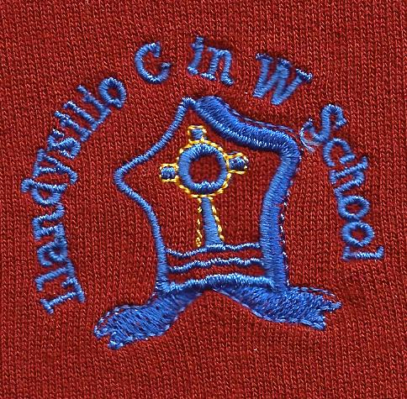

Behaviour & Discipline
Policy

BEHAVIOUR & DISCIPLINE POLICY
Introduction
This document is a statement of the aims, principles and strategies for developing appropriate behaviour Llandysilio C in W School.
The policy and practice is monitored and reviewed and has a termly Staff meeting focus.

Aims
The children will:
- respect the feelings of others - children & adults
- develop a pride of ownership of the school environment
- be encouraged to develop self control and subsequently take responsibility for their own actions
- understand that actions have consequence
- develop self discipline
- understand the boundaries of behaviour
- develop an emotional language
Objectives
The school will:
- ensure safety and well being of pupils and adults
- provide a secure and orderly environment necessary for effective teaching and learning to take place
- provide a positive atmosphere based on a sense of community and shared values
- reward and praise good behaviour to act as a model for all pupils
- make clear to all concerned via the ‘golden rules’ unacceptable types of behaviour
- protect children from self-inflicted abuse or injury
- provide a curriculum that supports social and emotional competence through the Dina school programme.
BEHAVIOUR MANAGEMENT
Behaviour Management should be an integral part of the curriculum which teaches appropriate social skills to all pupils thus allowing them to participate fully in the life of their home, school and local community. Good behaviour will be embedded in underlying attitudes which can only grow out of mutual respect and regard between adults and pupil.

Some examples of strategies to foster this mutual respect:
- Every person to be treated as an individual and their positive qualities praised and encouraged
- Staff to greet all pupils politely and expect to be greeted similarly
- All staff speak and expect to be spoken to in a polite way and to value the reply
- Smile and relate and show enthusiasm.
- Reward with praise whenever possible
- Dina school
From time to time it is advisable for all staff to reappraise their teaching styles, relationships with pupils and their manner and approach to individual pupils to ensure they are meeting the needs of all their pupils in a sensitive and caring way.
The curriculum should be so designed to motivate and give success and present a challenge for children to engage meaningfully with their activities and thus encourage and develop self discipline.
Positive attitudes and achievements should he fostered by:
- Praise and encouragement from the class teacher, Learning Support Assistants etc within their own classroom
- Praise from the teacher of another class (children to be sent at a mutually agreed convenient time)
- Praise from children within their own class
- Praise from pupils in another class
- Praise and a tangible reward ( e.g. Head Teacher reward sticker) from Head Teacher (pupils to be sent at a convenient agreed time)
- Mentioning in weekly golden book and singling out for praise in Assembly on Friday with certificate
- Displaying children's achievements attractively around the school
- Classroom reward system
- End of Term Certificates including attendance
Support for pupils with Challenging behaviours
We offer a variety of support including:
- In class low adult:pupil ratio
- In class 1:1 for specified period (on BSP)
- Home, school diaries
- Personal support plans
- Outside agency interventions

Parental support
We offer open door policy to Parents. They have access to Class Teachers on a daily basis, and the head or a Senior member of Staff.
Parents of children with challenging behaviour are offered ½ termly interviews with appropriate teachers. We signpost a family learning programmes that help parents to understand how their children learn and we subscribe to the Webster Stratton parenting programme.
SANCTIONS AGAINST UNACCEPTABLE BEHAVIOUR
- For minor displays of unacceptable behaviour, the class teacher reasoning with the child in the classroom setting is the first strategy, and often effective
- Short term withdrawal of privileges by the class teacher, e.g. playtime
- A behaviour book may be kept by the class teacher, setting the child attainable goals and
clear rewards. This may be extended as a diary between home & school, but this is in full consultation with Headteacher.
- Referral to the Head teacher.
- This action usually takes the form of reasoning with the pupil outside the classroom
- setting. Apologies are made by the offending pupil to any other pupil or staff member
- involved.
- In more extreme cases of unacceptable behaviour, activities the pupil enjoys may be withdrawn e.g. swimming.
- In exceptional circumstances, a pupil will be asked to be taken home by telephoning the parent. Only extreme behaviour warrants this, e.g. biting another child, hitting another child/adult.
All incidents are recorded in class teachers’ daily diary. This will be a fixed period – exclusion and the LEA policy will apply including meeting of the Pupil Discipline Committee (appendix)
- The SENCO is responsible with class teachers for drawing up Individual Behaviour Plans (IBPs).
- Parents will discuss these on a half termly basis.
The lunchtime supervisors report behaviour (positive or negative) to class teachers. It is the class teachers’ responsibility to seek this information.
It is the responsibility of all members of staff to take an active role in promoting good behaviour throughout the school.

