Llandysilio

Church in Wales School

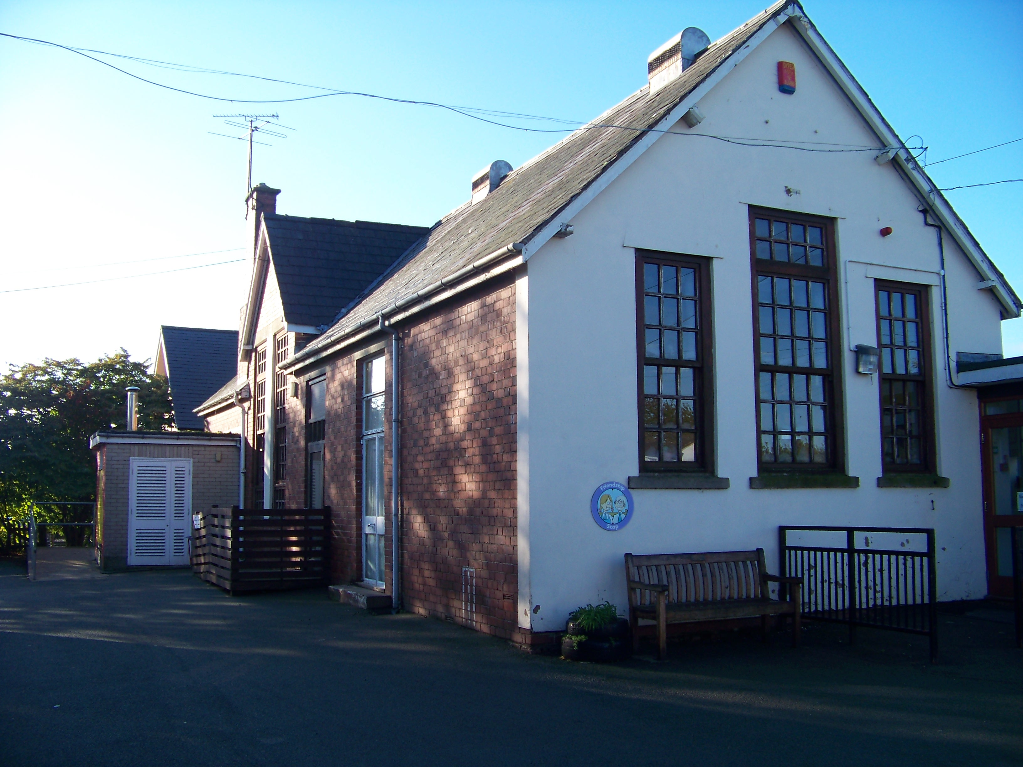

School Prospectus

2017/2018

Llandysilio Church in Wales School

(Voluntary Controlled)

Four Crosses

Llanymynech

Powys

SY22 6RB

Telephone – 01691 830339

Headteacher – Mrs A Williams

Chair of Governors - Mrs K Clewlow

Clerk to Governors – Mrs J Austin

Description of School – Church in Wales

Voluntary Controlled

Primary School

Language Category - English

Dear Parents,

If this is your first introduction to Llandysilio Church in Wales School, may I wish you and your child a very warm welcome? This prospectus has been prepared to give you a brief insight into our school life and I hope you find the information useful.

We are proud to be a Church School and we believe Christianity within the school permeates all we do with the children. A breakfast club is available from 8.00am to 8.30am each morning.

Our aim at Llandysilio is to provide a happy and secure environment in which we can offer each child a broad education encompassing all areas of the National Curriculum.

We believe that strong home-school links are vital and parents are very welcome in our school. We hold regular meetings to discuss children’s progress and we are seeking parents’ help to fundraise for extra equipment for the school.

This prospectus can only offer a brief introduction to our school but you are very welcome to come and visit us. Please telephone to make an appointment.

Yours sincerely,

Mrs A. Williams

Head teacher

Information about admissions

To apply for a place at the school, parents should contact -

Mrs Anne Wozencraft

School Admissions

Powys County Council,

Llandrindod Wells,

Powys

LD1 5LG

(01597 826455)

Admission forms are available from the school office or online from www.powys.gov.uk

Please note that pupils will be admitted in September in the year in which their 5th birthday falls.

In terms of school admissions, the Local Authority has adopted, in order of priority, the following criteria:

- Powys pupils with a Statement of Special Educational Need, which names a specific school.
- Looked after children in Powys.
- The presence of an elder brother/sister in the school (where the home remains in the allocation area of the school which applied in the year the elder child was first admitted.)
- The location of the home in relation to the school and alternative schools.
- Any special medical and social needs relating to the individual child.
- The presence of an elder brother/sister in the school when the family home is not in the original or current allocation area for the school.

Within each criterion, places will be allocated on the basis of the shortest walking distance to the school, in strict order of distance, up to the number of places available, the highest priority being given to the pupil living closet to the school.

Should your child not be allocated a place, there is an appeal process which you may choose to go through.

We aim to create a caring, happy and friendly environment within our school where each child is valued as an individual and encouraged to reach their own potential, regardless of ability, race or gender.

Our Mission Statement -

A caring, happy and creative environment in which ALL children can succeed.

The school sees itself as part of the community of Four Crosses. We view the process of education as a partnership between home and school; therefore we feel that it is important that parents and teachers feel confident to speak with one another in order to share both concerns and success about the children.

The school has a Home/School Agreement, which we ask parents and older pupils to read and agree to.

Links With The Church

Our school is a Church in Wales School, and as such, the school aims to serve its community by providing an education of the highest quality within the context of Christian belief and practice. It encourages an understanding of the meaning and significance of faith, and promotes Christian values through the experience it offers to all its pupils.

School Staff

Mrs. Amanda Williams — Headteacher

Mrs. Jen Pryce — Class Teacher

Mrs. Sian Rogers — Class Teacher

Miss Rosie Davies — Class Teacher

Miss Clare Jones — Class Teacher

Mrs. Carol Hughes — Class Teacher

Mrs. Helen Goddard — Teaching Assistant/

Mid-day Supervisor

Mrs. Lesley Leese — Teaching Assistant/

Mid-day Supervisor

Mrs. Sarah Hall — Teaching Assistant

Mrs. Jill Austin — School Secretary

Mrs. Val Davies — Cook

Mrs. Kath Jones — Mid-day Supervisor

Mrs. Eirian Edwards __ Breakfast Club Assistant

Mrs. Vicky Marshall __ Breakfast Club Assistant

Mr Chris Walgate — School Cleaner

Mrs. Val Davies — School Cleaner

Mr John Proctor — Peripatetic brass teacher

Organisation

The school is organised into 3 classes

- Foundation Phase
- Year 3&4
- Year 5&6

Children are able to start school in the September of the year in which their 5th birthday falls. Our aim is for your child to settle into school and to feel happy about coming to school.

When your child begins he or she should be able to go to the toilet unaided, put on a coat, eat with a knife and fork and to dress and undress with minimal help for swimming or P.E.

When your child has settled at school, he or she will start to learn to read, write and to learn about the world around them. In these early stages, a lot of learning will be through structured play situations. During the infant years the children will be laying the foundations for their learning later on, therefore we feel that it is important that children foster an enjoyment of learning and coming to school during the infant years. A strong emphasis is placed on the basic skills of literacy, mathematics and science in order that the children will be able to gain access to all areas of the curriculum later on in their school career.

Throughout the school the children are grouped in a mixture of friendship, age and ability groups depending upon the activity. Work can be organised individually, in groups or in whole class.

The work is delivered through topics, which encompass the whole of the National Curriculum and alongside these the children will work on mathematical and language based themes.

As your child progresses through the school, he or she will have the opportunity to discover and develop their own particular talents and interests - these may be academic, sporting, musical or creative.

School Times

School starts: 8.45am

Playtime: 10.30am-10.45am

Lunchtime: 12.00-1.00pm Foundation Phase

12.05-1.00pm KS2

School Finishes: 3.00pm

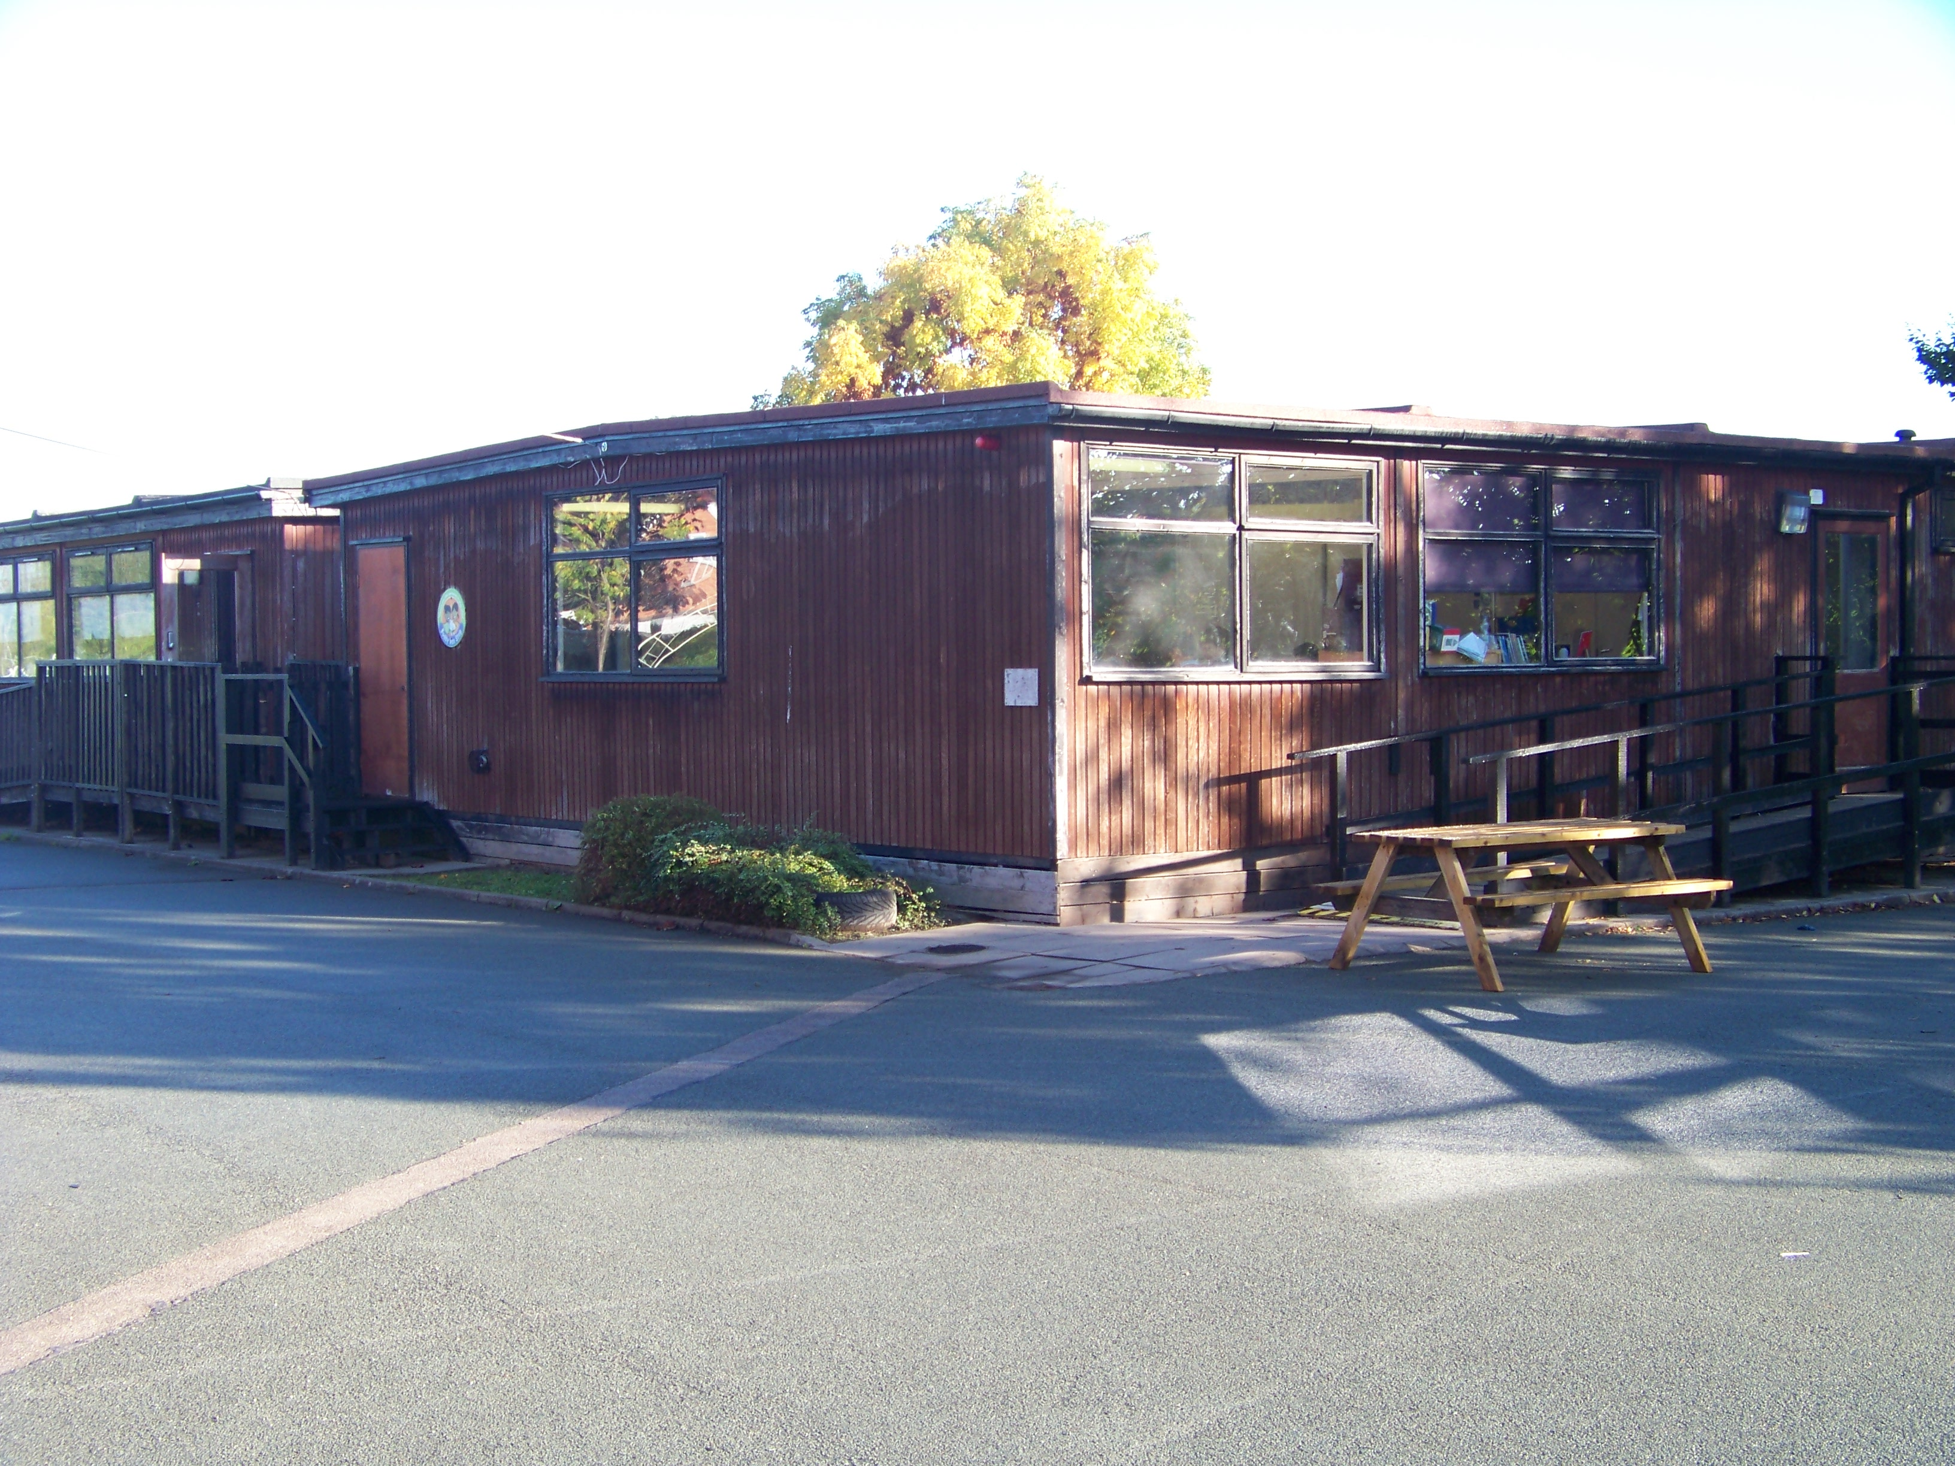

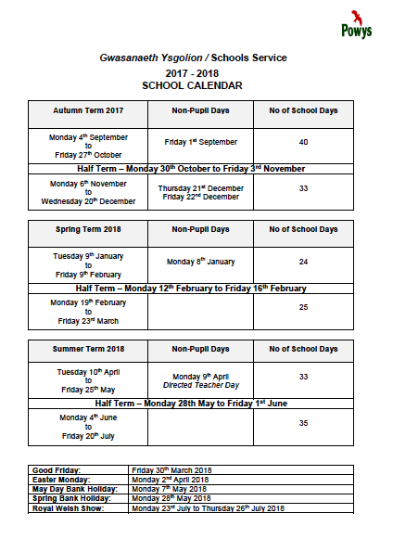

Breakfast Club

The school operates a breakfast club between 8am and 8.30am. Children must be dropped off at the hall at 8am where a member of the breakfast club staff will receive them. Children need to be in breakfast club by 8.20a.m.

School starts at 8.45am. For safety reasons, children should not enter the building unless a member of staff is on the premises.

Children should arrive between 8.30 and 8.45 am. The school doors open at 8.30 a.m, children should come into class immediately in the morning and remain the responsibility of the parents/carers until they do.

At the end of the school day, children should be collected from their designated door.

Playtime

During playtime children are expected to play outside unless it is raining or extremely hot or cold. A healthy snack only is permitted for morning playtime, this being fruit or vegetables.

All children in Foundation Phase are provided with free milk.

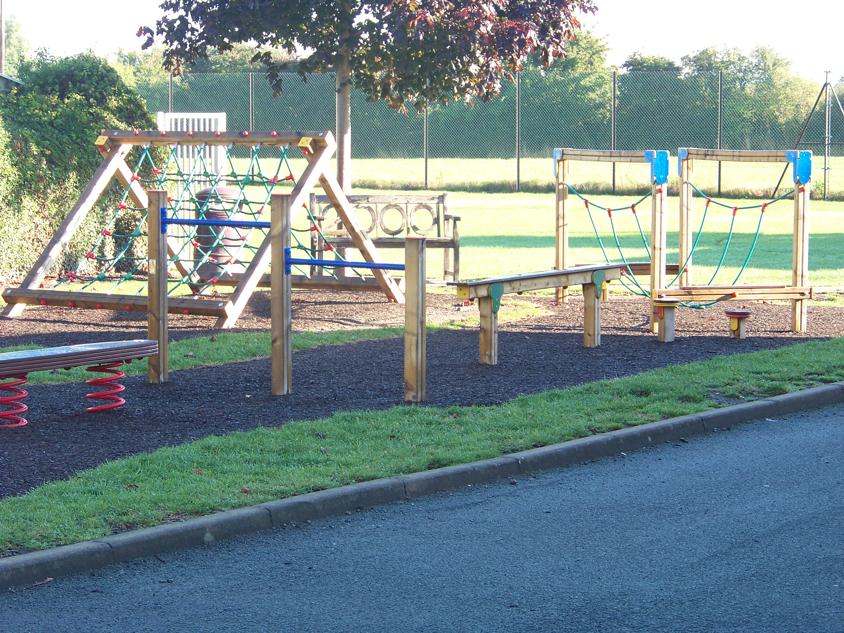

Fruit Tuck Shop

The school runs a fruit tuck shop each morning playtime, where pupils can buy various types of fruit for their snack. This is at a cost of 25p per day. This scheme was developed by the School Council and proves to be very popular with the pupils.

Lunchtime

At lunchtime, the children will be supervised by the midday supervisors. After lunch they will be expected to play outside unless it is wet they will be allowed to play games inside.

School Meals

School meals are cooked at Arddleen School and transported to school, the cost of meals are: £2.25

Payments of school dinners are now on a cashless system. You will be set up on this system when your child starts school. You may wish for your child to bring their own packed lunch and this is perfectly acceptable. If you are on a low income, your child may be eligible for free school meals, please contact the school for further details.

School Uniform

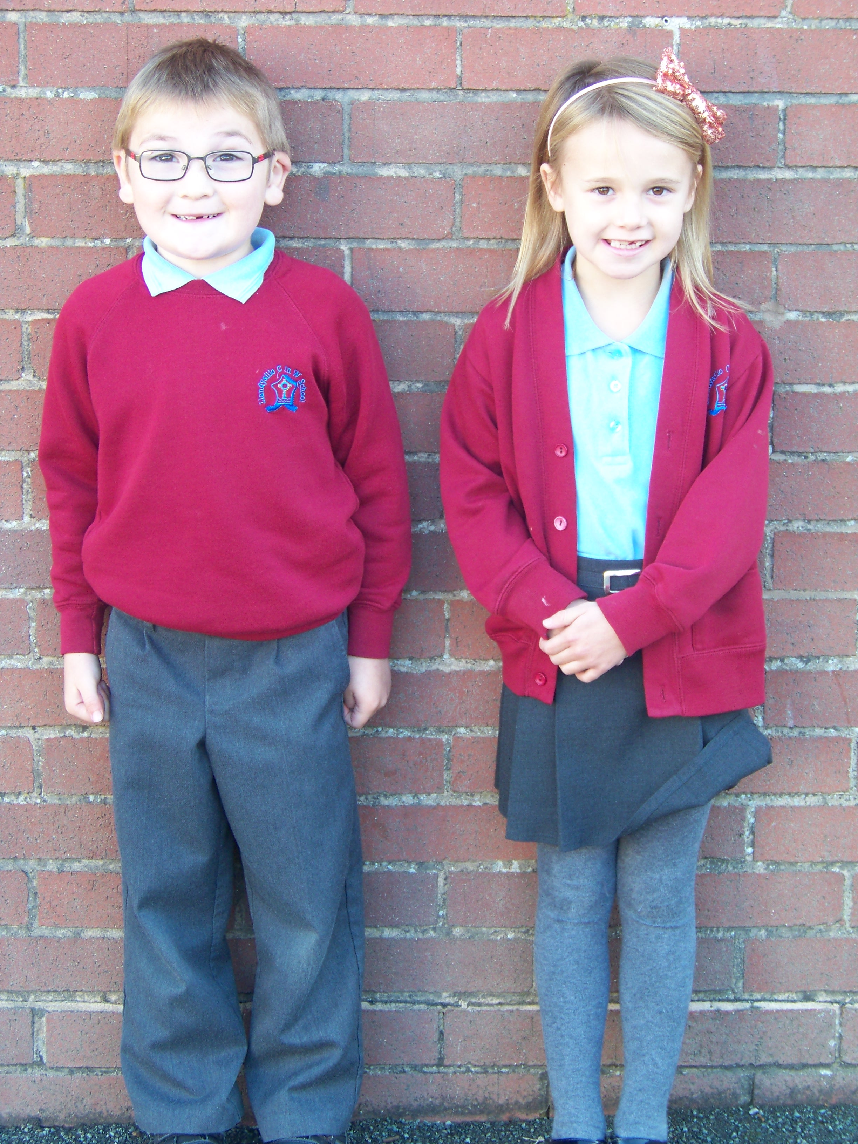

The children at Llandysilio School wear a uniform. This comprises of:

Boys – Burgundy school sweatshirt embroidered with school logo, sky blue polo shirt (either available from school with embroidered school logo or a plain sky blue polo shirt), grey school trousers or grey school shorts. No trainers to be worn please.

Girls – School sweatshirt and polo shirt as above, an optional school cardigan embroidered with the school logo, grey school skirt/pinafore dress/trousers/leggings. No trainers to be worn please. Red checked school dresses are often worn during the warmer weather.

PLEASE ENSURE THAT ALL UNIFORM IS MARKED WITH YOUR CHILD’S NAME.

PE Kit

It is essential that your child has a full PE kit in school. This comprises of black shorts, white t-shirt and plimsolls. Trainers are permitted for outdoor work.

Swimming trunks for boys and a one-piece swimming costume for girls. (No bikinis please)

Looked After Children

Mrs. Amanda Williams, Headteacher, is the member of staff responsible for promoting the educational achievement of Looked After Children. A policy is available from the school office.

Medicines in School

The teachers are not obliged to give any medication to children during the school day. However, it may be difficult for parents to come to school during the day in order to administer prescribed medicine. If teachers are asked to give your child prescribed medicine, you will be asked to complete a form regarding this.

Pupils With Disabilities

There is access to the main building via a ramp into the new building and the mobile classrooms have access via ramps.

There is a disabled toilet situated near to the staff room in the new building and also a disabled toilet with changing facilities in the main building. The school has a strategic equality plan in place, a copy is available to view form the school office.

Equal Opportunities

Please see the Equal Opportunities policy located in the school office.

Parents Evenings and School Reports

During the school year there will be an opportunity for you to come into school to discuss your child’s progress with the teacher. There is a parents evening for all pupils in the autumn and spring term.

You will receive an annual report in the summer term. Parents with children who have additional learning needs will be invited to review meetings on a termly basis.

The Curriculum

Llandysilio C in W School provides a stimulating learning environment within a caring and Christian atmosphere, where children are encouraged to develop to their full potential. We teach to the recommendations of the Foundation Phase for younger pupils and all National Curriculum subjects are

taught in Key stage 2 with an emphasis on “Skills Based Learning”.

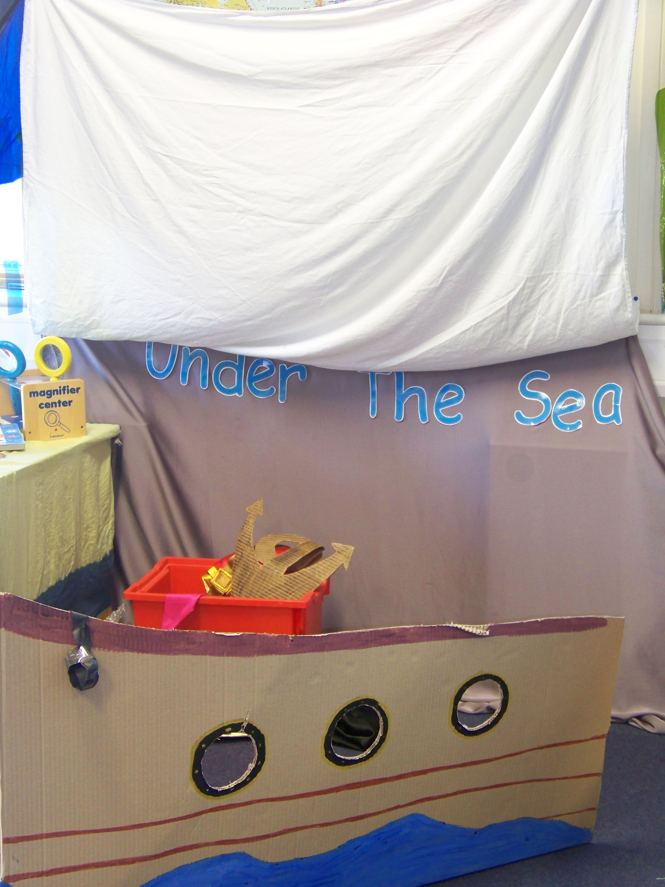

Foundation Phase

In the Foundation Phase we concentrate on the learning experiences, which enable children to be creative, imaginative and also allow them to have fun. Children are given opportunities to explore the world around them and to understand how things work through engaging in relevant practical activities across different developmental stages. We place emphasis on experiential learning and active involvement.

Children develop:
- skills and understanding
- personal, social, emotional, physical and intellectual well-being, so

as to develop the whole child
- positive attitudes to learning
- self-esteem and self-confidence to experiment, investigate, learn
- new things and form relationships
- creative, expressive and observational skills to encourage their

development as individuals with different ways of responding to

experiences
- Activities in the outdoors where they have first-hand experience

of solving problems and learn about conservation and sustainability

Key stage 2

In Key stage 2 pupils are encouraged to develop “adaptable skills”; we integrate subjects when possible and teach skills across the curriculum.

Maths

Maths is taught daily, we encourage children to develop different mathematical strategies which they apply to everyday situations. We make maths fun and are well resourced to support the learning.

English

We teach all aspects of English and study various genre. Children read individually and as part of a group daily. We participate in various organised events to support our teaching. We develop Speaking and Listening, Reading and Writing skills across both key stages.

Science

Children learn about all aspects of science and are encouraged to share ideas through scientific investigations. We make the learning fun and often use a practical approach to develop Scientific Enquiry.

ICT

We have a bank of laptops/ipads, which children regularly use. Children are taught various ICT skills and we integrate these with other subjects.

PSE

Personal Social Education is taught throughout all areas of school life. We encourage and promote good behaviour and manners. The children are encouraged to develop their own personalities and are seen as individual.

Welsh

Welsh is a core subject and is taught to all pupils. Formal lessons are given each week and the use of welsh language is encouraged throughout the school day. We encourage and promote bilingualism when possible. Curriculum Cymraeg is an important part of the ethos of the school and we participate in various Welsh celebrations.

Religious Education

As a Church in Wales School the whole ethos is naturally founded upon Christianity, which will be reflected in all curriculum areas not just Religious lessons. Children are given opportunities to learn and form ideas about Jesus, the Bible, Christian Worship and Tradition and the Faith, Belief and Values of the Church in Wales and other religions.

History

Children are encouraged to learn and research different periods from the past. We develop the children’s historical enquiry through research and investigation.

Geography

Children are taught mapping skills, about their local area and about industrial localities. They are encouraged to develop ideas through investigation and geographical studies.

Art

We aim to develop children’s artistic flare through various practical activities. We study different artists, visit galleries and encourage individualism.

DT

Technology is a practical subject in which pupils will investigate, design, make and evaluate in a safe and controlled environment.

Music

Children enjoy listening to and appreciating various composers. They are encouraged to participate in singing and playing a variety of musical instruments.

Physical Education

Games, dance, gymnastics and swimming are all compulsory elements of the National Curriculum and a child can only be excused from a lesson if a letter of explanation is sent in from home. Children have opportunities to take part in sporting competitions and extracurricular activities. Please ensure your child has the correct kit. The school is an active member of the Welshpool Area Sports Association and takes part in galas and inter-school sports competitions throughout the year.

Sex Education

Sex Education is integrated, where it occurs naturally, within the context of Natural Science, Religion and Personal and Social Education at levels appropriate to the pupils’ age and understanding. This is taught formally at the Year 6. Parents have a right to with draw their children from these lessons.

Use of Internet and E-mail

Children will be using computers from their nursery year through to year 6. They will at times use the Internet. We have a filtering system in place hosted by Powys County Council, however, there will inevitably be times when a website slips through the net. A member of staff will be in the vicinity of the children when using the Internet and will ensure that they do their utmost to prevent a pupil from having access to unsuitable sites.

Parents are required to sign up to our acceptable use policy.

Transition to Secondary School

Llandysilio School resides within the Welshpool High School Cluster Catchment; we also have links with Llanfyllin High School. In their final year at school, Year 6 children have the opportunity to visit both of these schools in order that a choice can be made and the transfer can be less daunting.

Homework

The children will, at times be given tasks to do at home relating to their class work. If you would like to know how to help your child with any aspects of their work, please do not hesitate to contact your child’s teacher.

Your child will bring home their reading book on a regular basis and we ask that you will take the time to listen to them read at home and comment in their reading diary.

Collective Worship

An act of Collective Worship is held each day and the Vicar/Leader of Worship visits the school weekly. Opportunities are provided for children to observe the main Christian Festivals in the Church year. Parents have a right to withdraw their children from collective worship and Religion lessons and should discuss this matter and alternative arrangements with the Headteacher.

Additional Learning Needs - Helping Your Child to Achieve

We all need help from time to time to overcome difficulties and move forward in our life. Special Educational Needs and Additional Learning Needs is the same. We at Llandysilio Church in Wales Primary School regard all children as special. Some children may require a little help to overcome difficulties in a particular area.

Perhaps the difficulty will be overcome quickly and no additional, long-term help is required. Some children, however, continue to need help and support and an Individual Education Plan (IEP) may be drawn up. An IEP sets out small steps, which a child needs to accomplish before they can move on with their learning. IEPs are written and reviewed each term. Teaching Assistants work closely alongside teaching staff to support all children, but especially those with an IEP.As in all schools, each of our classes has children with a special need. This may be a hearing, sight, speech and co-ordination impairment, behavioural and emotional difficulties and specific learning problems. Within every class there are children with a wide range of abilities, and staff aim to cater for these varying needs within the classroom situation. Sometimes children are withdrawn from the classroom setting either individually or in a small group. A teaching assistant is able to give them more focused support. When there is continued concern about a child’s progress, additional advice and/or assessment may be requested from the Educational Psychology Team. Some children may then require a statement of Special Educational Needs. This ensures that the school is able to provide any support necessary with the appropriate guidance from additional professionals.

Educational Visits

In order to enhance the teaching that is happening at school, we often make visits to relevant places of interest. These visits are a very important part of your child’s learning and we are dependent upon parental help in order for these visits to go ahead. We need help in order for there to be adequate pupil to adult ratio. We also ask parents to make a voluntary contribution towards the cost of these visits, it should be noted that the PTA make a termly contribution to each class to support learning. Should not enough parents make voluntary contributions then it is not possible for the visit to take place. If any parent has problems with contributing, please contact the Headteacher, it may be possible to pay by installments or make other arrangements.

Swimming

We go swimming at the Flash on Thursday mornings in half-termly blocks. The PTA 100 club partially funds the transport and we ask for a contribution of £1.50 per trip. During swimming lessons the children are supervised by the teachers, a qualified swimming teacher and a poolside attendant.

Extra-Curricular Activities.

We are very proud of our sporting achievements here at Llandysilio C in W School. We offer a range of sporting after school activities throughout the year. These range from Soccerholics, netball, singing and we also work with local clubs to ensure children have opportunity to develop their skills further.

Curriculum Documentation

Policies regarding the curriculum are available on our website and a paper copy in school for parents to read.

Complaints

If you are unhappy about any aspect of your child’s education curricular or pastoral please contact the Headteacher. Most problems can be sorted out in school. If you are still unhappy, please contact the Chair of Governors. If you still feel unsatisfied The LEA can be contacted via the Challenge Advisor. A formal complaints policy and procedure is available from the main office.

Complaints About the Curriculum

The LEA are required to establish procedures, approved by the National Assembly for Wales, for handling complaints about the actions of Governing Bodies and LEA’s on the curriculum. Information about arrangements for making complaints about the curriculum can be found in the Complaints Procedure Policy in the school office.

Music Lessons

In addition to class music, your child at from Year 1 and above has the opportunity to learn piano, drums and brass at Year 2 and above. These lessons take place during the school day; parents are asked to pay for these lessons. Should you wish your child to learn another instrument then the school will endeavour to make arrangements for tuition.

Assessment and Testing

Your child’s teacher will continually assess your child’s progress, but the school carries out more formal tests at specific times. In May of Year 6 and Year 2 assessments are made. Year 4 pupils take part in CAT’s testing in the Autumn term and Reception children are assessed for base-line. In-house reading tests are carried out three times a year. National Numeracy and Literacy tests take place in the summer term from Year 2 upwards.

School Council

The school council is a representative group of pupils elected by their peers

to discuss matters about their education and raise concerns with the senior managers and governors in our school. Their peers elect members from each year group from Year 2 upwards. The school council meets once a half term in which agenda items include issues from the development plan and any items the members which to discuss.

Eco School Award

Eco-Schools is an international award programme that guides schools on

their sustainable journey, providing a framework to help embed these principles into the heart of school life. At Llandysilio School the children are the driving force behind Eco-Schools – they lead the eco-committee and help carry out an audit to assess the environmental performance of our school. Through consultation with the rest of the school and the wider community the pupils decide which environmental themes they want to address and how they are going to do it. The school has acquired the Silver Award and we are now working our way to achieve the Green Flag status.

Healthy School Award

The school has acquired four leaves of the Healthy Schools Awards. As a school we aim to give pupils a greater understanding of themselves by covering aspects of diet, hygiene and exercise. Children are encouraged to drink water regularly throughout the day. Children are allowed to fill their bottles from the water coolers at break and lunchtimes.

Charging and Remissions

A copy of the Charging and Remissions policy is available from the school office.

Safeguarding

We follow the All Wales Child Protection Procedures 2008 that have been endorsed by the Local Safeguarding Children Board. The Designated Teacher for Child Protection in this school is: Mrs. A Williams. The Deputy Designated Teacher for Child Protection in this school is: Mrs. C Hughes.

The following procedures are followed:
If the child is in immediate danger, the police should be called.
If the child is not in immediate danger, Children’s Services should be called and a written referral must be submitted within two days.
Always seek advice and support.
It is essential that all agencies work together to protect children. To delay reporting a suspicion of abuse could be disastrous. Referrals should be made to Children’s Services as soon as a problem, suspicion or concern becomes apparent, and certainly within 24 hours. Referrals to Children’s Services in Powys should be made to the Duty Officer based at:-
•Neuadd Maldwyn, Welshpool 01938 552017
•The Park, Newtown 01686 617520/1
•1 High Street, Llandrindod Wells 01597 827325
•Neuadd Brycheiniog, Brecon, 01874 624298
•Hendreladus, Ystradgynlais, 01639 844595
•Out of Office Hours 0845 757 3818

School Comparative Information
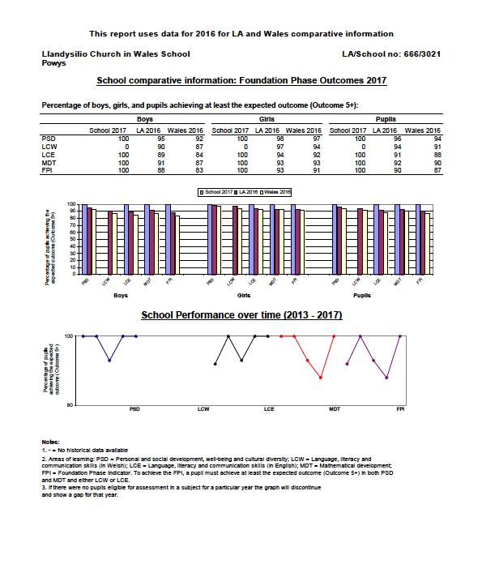

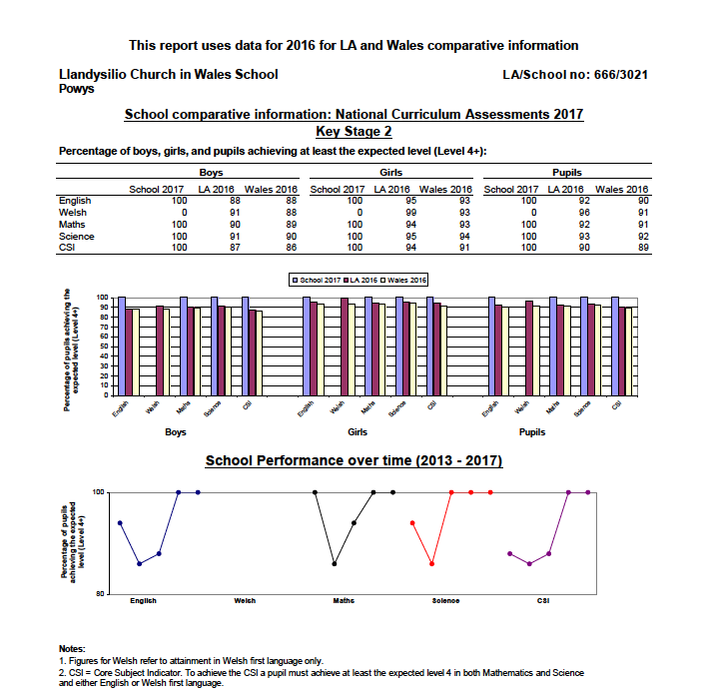

Attendance
Average daily attendance 2016/17= 96.6%
Authorised absence = 3.37%
Unauthorised absence = 0.6%

PARENTS IN PARTNERSHIP

At Llandysilio C in W School we aim to create a genuine and meaningful partnership between school and home. There are many opportunities for parents to become involved in the work of the school and to gain a greater understanding of school life.

Communication with parents/carers

The school communicates with parents and carers in various different ways e.g. newsletters, questionnaires, parent’s consultation and informal evenings. Parents are invited to a range of events throughout the school year: parents evenings, concerts, end of term assemblies, church services, Eisteddfod and others. However, we welcome you into school throughout the year. If you have any query concerning your child, we will be only too happy to see you.

If you are able to offer some help in the classroom during the school day there are a variety of different activities such as:

- Listening to children read
- Supporting the computer work
- Play maths, science or language games
- Helping with art, craft or technology

However, in line with Council guidelines, we ask that any classroom volunteers be subject to a DBS check.

Llandysilio Parent Teachers Association

We have a thriving Parent Teachers Association, which we hope all parents will support. Over the year they will organise fund-raising and social events, there is a 100 club with monthly prizes, which helps fund the cost of our transport to swimming lessons. The committee is made up as follows:

President - Ken Evans

Chair- Sam Hodgkiss

Treasurer- Sarah Pearce

Secretary- Vicky Marshall

